Pharmacy Concepts
A Domain and Solution Overview

Participant Guide

Cerner Millennium PharmNet

Table of Contents
1. Introduction 5
Overview and Objectives 5
Place in the Curriculum 6
Guidelines for Participants with Relevant Experience 8
Length and Requirements 8
Evaluation 8
Project Code 9
Task Summary 10
Pharmacy Overview 10
PharmNet Overview 10
PharmNet Walk Through 10
Readiness Assessment 10
2. Pharmacy Overview 11
Facing the Facts: Issues in the Pharmacy 11
The Pharmacy and the Medication Process 12
How Does the Medication Process Work? 12
Beyond the Medication Process 13
Additional Responsibilities for the Pharmacy 13
A Few Key Pharmacy Basics 13
What is a Medication Order? 13
What is a Formulary? 14
How are Medications Distributed? 14
What do you mean - Medications are administered? 15
3. The Pharmacy: Its Players and Its Processes 16
Who are the Pharmacy Players? 16
What are the Pharmacy Processes? 17
1. Department Materials Management - Inventory Control Processes 18
2. Medication Order Entry and Maintenance Processes 20
3. Integrated Medication Process 22
4. Dispensing Processes 24
5. Charge and Credit Capture Process 29
6. Pharmacy Clinical Documentation Process 33
7. Clinical Reporting Process 35
4. PharmNet Overview 37
PharmNet Introduction 37
More About PharmNet 37
Medication Manager (phamedmgr.exe) 37
Charge/Credit (phachargecredit.exe) 38
Batch Dispense (phabatchdispense.exe) 38
Batch Report Print (phabatchreport.exe) 39
Multum 40
5. PharmNet Web-based Training & Application Component Review 41
PharmNet WBT Completion Instructions 41
How Long Will it Take? 41
Is There an Additional Charge? 41
How Do I Get Started? 41
Components of the PharmNet Functionality 44
Using Medication Manager 44
Using Batch Dispense 46
Using Batch Report 48
Using Charge/Credit 50
6. Integration 52
Integrated Medication Process 52
PowerOrders 52
PowerChart 52
Discern Expert and Adverse Drug Event Prevention Solutions 52
7. Resources 54
Cerner Millennium Support Guide (CMSG) 54
8. Readiness Assessment 56
9. Glossary of Terms 58
Sources 63

Introduction

Overview and Objectives
RECOMMENDED READING GUIDELINES:

The Introduction chapter is recommended for all participants.
Pharmacy Concepts is a self-study, introductory course that was designed to provide foundational knowledge related to the pharmacy domain and Cerner’s corresponding solution, PharmNet®.
As part of this learning event, participants will be able to:
- Identify the basic pharmacy processes, functions, organization, and terms common to the industry.
- Outline how a pharmacy works and the functions it performs in the hospital.
- List the end-user applications that make up the PharmNet suite and summarize the key functions of each.
- Correlate the key processes and goals of the hospital pharmacy and the support these are provided using Cerner’s PharmNet solution.
- Use the basic functions associated with key end-user PharmNet applications.
- Locate and use various resources commonly used to support PharmNet.

Place in the Curriculum
To best meet the needs of our clients and associates, the PharmNet curriculum is comprised of three components which should be taken in the order depicted below.
You Are Here
1) Pharmacy Concepts
(self-study)

2) PharmNet Inpatient Design and Build – Basics
(classroom-based)

3) PharmNet Inpatient Design and Build – Advanced

1. Pharmacy Concepts
This learning event is designed to provide background on the pharmacy domain and PharmNet end-user functionality, as well as the resources often used to support PharmNet solutions.

Delivery Method | Self-Study
Length | 4 – 8 Hours
Timing | To be completed as a pre-requisite prior to the beginning of PharmNet: Design and Build Basic class
Audience | - Participants with little to no experience in a pharmacy department  - Participants with little to no knowledge of/experience with PharmNet solutions  Participants with experience in some but not all of the areas listed above may complete only the needed areas of the course (for details, see the Guidelines for Participants with Relevant Experience explanation in the following section).

2. PharmNet Inpatient Design and Build – Basics
This learning event is designed to provide in-depth knowledge and hands-on practice with regard to the design and build of PharmNet functionality. This learning event focuses on the basic design approaches and the build steps to support the PharmNet solutions. Design and build activities focus on the medication order core build, the PharmNet database build, and the PharmNet formulary product build, as well as additional build items such as PharmNet reports, charge, and security builds.

Delivery Method | Classroom-based
Length | 4 Days
Timing | Varies
Audience | Varies

3. PharmNet Inpatient Design and Build - Advanced
This learning event is designed to provide advanced knowledge and hands-on practice with regard to the designing, building, testing, and troubleshooting of PharmNet solutions. This learning event focuses on advanced design and build approaches, as well as the recommended testing and troubleshooting approaches used to support the PharmNet solutions. Specific activities focus on troubleshooting and resolving application-related error messages, as well as designing and building to support automated dispensing devices.

Delivery Method | Classroom-based
Length | 4 Days
Timing | Varies
Audience | Varies

Guidelines for Participants with Relevant Experience
Some participants may have significant experience with the pharmacy domain and/or PharmNet. The table below provides experience to need guidelines for completing this self study learning event.

Experience | Need
Participants with 1 to 2 years pharmacy-related experience | May be able to skim or skip Chapters 2, 3, and 9 of Pharmacy Concepts
Participants experienced with Cerner PharmNet solutions | May be able to skim or skip Chapters 4 and 5 of Pharmacy Concepts
All Participants | It is recommended that all participants review Chapters 1, 6, 7, and 8

Length and Requirements
Depending on your previous knowledge of the content, you should plan to spend between three to eight hours completing this self-study.
It is very important that you spend the time necessary to learn about the pharmacy department, its functions and related workflow, and how Cerner Millennium® PharmNet might be used to streamline these. Dig into and exhaust your resources! You will be expected to walk in the door the morning of the workshop with an understanding of the content addressed in this self study. If you do not, you will be behind before we even start.
You will need to be connected to the network for some of that time in order to complete a WBT (Web-based training). In addition, if you have access to a domain with the Basic Data Set (BDS) loaded, such as the CVU Play Environment, you are encouraged to walk through the BDS script for a more in depth knowledge of the solution.

Evaluation
Participants will complete a readiness assessment prior to beginning PharmNet Inpatient Design and Build – Basics course. Readiness assessment details are included in Chapter 8 of this participant guide.

Project Code
The project code to use for your time spent on this self study learning event is 167053.

Task Summary
Pharmacy Overview
- Read the Pharmacy Overview included within this packet.
PharmNet Overview
- Read the PharmNet Introduction [M2003-2004] in the Cerner Millennium Support Guide (CMSG)*. This document can be found in the Cerner Millennium Support Guide>Applications tab. Select PharmNet – Inpatient and from the Overview category, select the Introduction [M2003-2004]. This document includes approximately nine pages.
- Read Providing Care Solutions in the Cerner Millennium Support Guide (CMSG)*. This document can be found in the Cerner Millennium Support Guide>Process tab. Select Providing Care Solutions from the Introduction category. Once in the document, navigate to The PharmNet Management System section. This section of the document includes approximately three pages.
PharmNet Walk Through
- Complete the Cerner Millennium PharmNet WBT – 2003.01
Readiness Assessment
- Complete the readiness assessment.

* The CMSG is accessible from Cerner Knowledge Network (CKN) and myCerner. From CKN, the CMSG is accessed using the link in the left-hand navigation under Service / Troubleshooting or using the link listed in Quick Picks the right side of the CKN home page. From myCerner, you select the Solutions or IP Development tab and click the link listed in Quick Picks (it is the first item listed).

Pharmacy Overview
Facing the Facts: Issues in the Pharmacy
RECOMMENDED READING GUIDELINES:

The Pharmacy Overview chapter is recommended for participants with less than one to two years of pharmacy-related experience.
- Although nine of ten pharmacists are satisfied with their career choice and that turnover is fairly low (as low as 11percent yearly), nearly 70 percent of pharmacists classified their workload as heavy or very heavy.
- The American Society of Health-System Pharmacies reported a 5.6 percent vacancy (approximately 2,800) unfilled hospital pharmacist positions.
- North Carolina’s board of pharmacy recently pioneered a regulation that holds employers and pharmacists equally liable for medication errors if the outpatient pharmacy’s daily prescription load is over 150. They also proposed a regulation prohibiting pharmacy owners from requiring their pharmacists to work more than twelve continuous hours per workday.
- The National Association of Chain Drug Stores estimates that by 2006, pharmacists will be expected to fill almost four billion prescriptions, up from three billion in 2001.
- A study out of British Columbia estimated that more than 18 percent of all medication orders processed have a problem related to it such as illegibility, incompleteness, inappropriate dose and directions, or non-formulary drug selection.
- This same study estimated that the time spent resolving problems associated with medication orders can amount to more than four hours in an eight hour shift.

The Pharmacy and the Medication Process
At its most basic level, the purpose of a pharmacy is to supply the medication needed for patient care. Most pharmacies, however, provide far more than a medication off the shelf. The true purpose of a pharmacy is to help patients make the best use of their medication, to ensure the safe and appropriate use of the medication, and to check the medication use process (from prescribing to dispensing to administering to monitoring).
The hospital pharmacy, and in particular the pharmacist, plays a vital role on the patient care team and is a critical player in managing the medication process. Its overall mission is to manage the safe, effective, timely, and cost-effective use of drugs in the hospital or healthcare system.
How Does the Medication Process Work?
A typical interaction with the hospital pharmacy begins with the physician placing a medication (drug) order for a patient. In a perfect scenario, the medication order is entered by the physician into a computerized system. (For more information about a medication order, see the section titled “What is a Medication Order?”) This medication order is then automatically routed to the pharmacy where the pharmacist can process the order. In many cases, however, the physician documents the order using a carbon-copy order form. The original copy generally stays with the patient’s chart or medical record and the other copy is sent to the pharmacy. The order can be received by the pharmacy by various methods: fax, pneumatic tube, or messenger (courier).
Once the medication order has been received, if the order is not already in a computerized system, the pharmacy technician enters the order into the patient’s profile in the pharmacy computer system. Following this step, the medication order is ready to be processed. The order is evaluated or verified by the pharmacist and checked against the patient’s medication profile. At this point, the patient’s medication allergies and medication use history should be documented and available for the pharmacist to review. Assuming the order is problem-free, the pharmacist can begin the heart of the dispensing process.
The dispensing process is much more than “counting and pouring” the medication into a bottle and “licking and sticking” on the label. The process includes retrieving the drug or ingredients, preparing or compounding (making) the medication, preparing and labeling the container, and finally, rechecking and dispensing the medication to the appropriate floor or patient care unit. To complete the dispensing process, the pharmacy must also apply the appropriate charges for the medication to the patient’s profile.
At this point, the medication is delivered to the patient’s floor and is ready to be administered to the patient. Although this task typically falls to one of the primary care nurses, the pharmacist may follow-up on this order by tracking medication use compliance (is the medication being used as prescribed), by tracking patient outcomes (how did the patient respond to the medication), and certainly, by tracking the safety of the medication (were there any adverse drug reactions, interactions, or medication errors).

Beyond the Medication Process
Additional Responsibilities for the Pharmacy
The scenario above only describes only one facet of the services the pharmacy department offers to the hospital. The pharmacy department is also responsible for controlling all drugs in the hospital. This includes storage and inventory control, as well as the management and control of the healthcare organization’s formulary. Formulary management includes the control of the proper use of drugs under investigation (for clinical research or under consideration for the hospital formulary) and drug samples. The pharmacy is also responsible for overseeing the medication use process and drafting the policies and procedures to support this process. These are usually documented as part of the formulary.
Finally, the pharmacy, in particular the pharmacist as part of the patient care team, plays another critical role. Do you recall the last time you went to the pharmacy to have prescription filled? The pharmacist may have asked you if you had any medication allergies and probably talked you through the proper use of the medication and any potential side effects. He or she may have also talked to you about the previous time you took this same medication and asked if it was working for you and may even have had suggestions on how to improve your condition beyond the medication. Although this scenario describes a pharmacist in a retail setting, slowly, but surely a trend is emerging in hospitals for the pharmacist to begin providing a specialized form of direct patient care. This is known as pharmaceutical care and it is increasing the amount of clinical pharmacy support (supporting the physicians and their needs).

A Few Key Pharmacy Basics
What is a Medication Order?
Before venturing too much further into the pharmacy world, let us make sure we have covered some of the basics. The most basic patient care element that impacts the pharmacy is the medication order. But what IS a medication order? Although legally a prescription is different from a medication order, they are essentially the same thing. A prescription is an order, usually written by a physician (or a physician’s assistant or nurse practitioner, if they have prescribing privileges), requesting a pharmacist to dispense specific medication for a patient at a particular time. A prescription must include the date, the name and address of the patient, the prescription including the name, strength, and quantity of medication, and instructions on how to take the medication, along with refill information and the prescriber’s signature.
A medication order, again, the term used for a prescription in healthcare settings, differs from a prescription only in definition, legal status, and how they are written. A medication order is written to a pharmacist by a physician or other legal prescriber for an inpatient of a hospital. The medication order includes the patient’s name, room number or location in the hospital, and, most likely, a series of orders, rather than one at a time as you would see with a prescription. The prescriber still must include the name, strength, and quantity of medication and instructions on how to administer the medication, in addition to their signature.
Additionally, the prescriber is typically limited to using the drugs and medications that have been approved by the healthcare organization and are included in the hospital formulary.
What is a Formulary?
A formulary is a list of drugs approved by the medical staff of that organization for use within the organization. Drugs included in the formulary are usually selected based on relative product safety, efficacy, and effectiveness. This list is established, managed, and maintained by a hospital committee composed primarily of physicians, nurses, and pharmacists. This committee is commonly known as the pharmacy and therapeutics committee (often referred to as the p and t committee).
How are Medications Distributed?
Medications are distributed throughout the hospital and other healthcare settings using three primary systems: floor stock, unit-dose, and IV additive mixtures.
- Floor Stock medication is stored on the patient care units and is used on an as needed basis by the nursing staff. The most common medications kept as floor stock includes narcotics, various intravenous solutions (IVs), and emergency drugs. Some units, such as the emergency room (ER), intensive care units (ICUs), operating rooms (ORs), and post-anesthesia care unit (PACU), typically have more and varied floor stock to support their medication needs.
- Unit-Dose medications are dispensed one dose at a time so that it is ready to be administered without further preparation. Typically the pharmacy dispenses enough medication doses for the patient for the next shift or next 24-hour period. With the unit-dose distribution method, the pharmacy prepares the doses and sends them to the floor while the nursing staff administers the medication and documents the administration and response the patient had to the medication.
- IV Additive Mixtures (Admixtures). IV additives are drugs added to intravenous (IV) solutions. Joint Commission on Accreditation of Healthcare Organizations (JCAHO) and American Society of Health-System Pharmacists (ASHP) recommend that IV admixtures be prepared in the pharmacy under aseptic conditions. For this reason, most IV admixtures are prepared in the pharmacy and then distributed to the patient care unit at the time they are needed for administration.
What do you mean - Medications are administered?
No. The phrase “medications are ready for administration” does not mean that the medications are ready to be managed by some governmental organization or that paperwork needs to be completed regarding the medication. Administering a medication is the physical act of giving the medication to the patient, for example, a shot is given, an IV solution is set up, or a pill is given to the patient to swallow. Once the medication is administered, the administration is recorded in the patient chart, typically in the Medication Administration Record (MAR). This record includes what was given, how much, and when.

The Pharmacy: Its Players and Its Processes
In previous years, the pharmacy was simply looked at as the “drug store” and the pharmacist a “druggist”. With the increasing responsibilities placed on the pharmacy and the critical, clinical role pharmacists are asked to play in the medications process, however, the scope of this department continues to expand far beyond the “drug store” metaphor.
RECOMMENDED READING GUIDELINES:

The Pharmacy: Its Players and Its Processes chapter is recommended for participants with less than one to two years of pharmacy-related experience.

Who are the Pharmacy Players?
Hospital pharmacies are organized in different ways but typically include pharmacists, managers, pharmacy technicians, and other pharmacy assistants such as couriers, clerks, and secretaries.
- Pharmacists usually hold a B.S. degree in pharmacy or a Pharm.D. degree. Pharmacists holding either degree are considered a registered pharmacist or RPH. The Pharm.D. degree includes additional clinical experience. Pharmacists manage the medication use process from storing to controlling to prescribing to verifying to dispensing to administering to monitoring. In addition, they provide clinical pharmaceutical care to patients and support physicians and nurses with this same expertise.
- Pharmacy Managers (including Pharmacy Director) typically have completed a pharmacy residency as well as an MBA or Master’s in healthcare administration. The Director is accountable to the hospital administration. The pharmacy managers help run the pharmacy and often represent the pharmacy on outside committees and projects.
- Pharmacy Technicians usually have been formally trained through a work or school program. Pharmacy technicians often participate in the medication use process by entering patient information and orders in the pharmacy system and preparing or compounding medications to be dispensed. They also help support the inventory control process by ordering and inventorying drugs.
- Pharmacy Assistants normally do not have any formal training in the pharmacy. They typically unpack and stock shelves, deliver medications to the patient care units, and/or perform clerical functions.

What are the Pharmacy Processes?
At this point in your reading, you should have a pretty good idea what a hospital pharmacy does, what it is responsible for, who does the work, and how it integrates with the clinical operations in the healthcare setting. It should be more than apparent that the hospital pharmacy is much more than a “drug store”. Let us take a closer look at the work the pharmacy does. We are going to investigate this work by looking at the various processes that support the work done in the pharmacy. These include the following:
- Department Materials Management - Inventory Control processes. This includes Inventory Management and Formulary Management functions.
- Medication Order Entry and Maintenance processes (also known collectively as the Medication Order Management processes). This includes functions such as Pharmacy Order Entry, Dose Range Checking, and clinical decision-making support using reference information.
- Integrated Medication process. In the case where physicians are entering the medication orders, the pharmacy role changes. The functions performed in this process include order verification and monitoring the patient’s medication therapy.
- Dispensing processes. This includes Initial Dose and Continuing Order and Batch Fill dispensing processes.
- Charge and Credit Capture process.
- Pharmacy Clinical Documentation process including Clinical Documentation Management and Clinical Management and Drug Utilization Review functions.
- Clinical Reporting process.
1. Department Materials Management - Inventory Control Processes
Medication inventory represents a significant cost to healthcare organizations. At the same time, the dispensing of medication usually represents the largest revenue stream. The accurate and timely management of pharmacy inventory and the organization’s formulary enables the pharmacy department to adjust the formulary and inventory levels based on clinical needs and activity with a minimum of overhead cost being tied up in unused medications sitting on the shelf.
Inventory Management and Replenishment
Management of medication inventory in the pharmacy falls into two broad categories: cost center transfers and clinically driven inventory adjustments.
Cost Center Transfers
Cost center transfers include the transfer of medications to a patient care unit as floor stock, as well as supplying medications to procedure areas where the medication charge already is bundled into the cost of the procedure. These transactions are recorded for budget purposes, but a specific patient charge is not created.

Clinically Driven Inventory Adjustments
Clinically driven inventory management links clinical activity, such as pharmacy dispensing or nursing administration, directly to available inventory levels of medications.
Medication inventory replenishment management naturally follows with inventory tracking and control. This includes replenishing medication stock at inventory locations throughout the healthcare organization, as well as ordering inventory from suppliers and other outside sources. The work responsibilities for these activities are distributed between the pharmacy department and the inventory-control officials at each organization.
Formulary Management
There is a natural link between the pharmacy inventory and the healthcare organization formulary, the formulary defines what drugs are approved for use within the organization including where a product can be dispensed from for clinical activity while the pharmacy inventory defines where a product is stored physically, along with the inventory levels for that product.
Common Pharmacy Issues with Materials Management and Inventory Control
Medication inventory (medication kept in stock for immediate use) in a hospital is in a constant state of change. It is regularly being distributed to various pharmacy locations throughout the hospital and from each of these locations is dispensed to floors and units for patient use. In addition, medication manufacturers frequently have shortages of medications. The pharmacy department must carefully monitor how much and where medications are stocked within the hospital, monitor the quantity on hand at each location and determine and monitor the threshold for each medication at which additional product must be reordered. When inventory is not closely monitored, a shortage of the medication in the facility could result in the ordered medication not being immediately available for administration.
2. Medication Order Entry and Maintenance Processes
The medication order entry and maintenance processes are probably the most familiar of the pharmacy processes. These processes are initiated by a physician writing a new order or modifying an existing order. Upon communication of the new order or order modification, the order is prioritized for entry and then the new order or order change is entered into the pharmacy system. Typically, one of two pharmacy staff members enters medication orders when they are received by the pharmacy, the pharmacist or the pharmacy technician. Once entered into the system, the pharmacist reviews the patient’s medication profile, and then the order is processed and dispensed to the patient care unit as required.
Dose Range Checking (DRC)
Dose Range Checking in Cerner Millennium content is a system-automated method of comparing a medication order’s dose against pre-established safe ranges for the medication. Medication doses can be evaluated against criteria specific to patient age, patient weight, patient body surface area (BSA), frequency, and route of administration.
Upon determination that a dose is out of the safe/effective range, an interactive alert notifies the ordering clinician that the dose entered is outside of the ranges, and the predefined ranges are displayed for clinical review.
Multum Information Services, Inc., a Cerner company based in Denver, Colorado, founded to develop innovative and cost-effective solutions for the growing problem of adverse drug events (ADEs), provides the Dose Range content.
Reference Information (Clinical-Decision Support)
Cerner uses reference databases supplied by Multum Information Services, Inc. to support the initial database build, to provide ongoing maintenance of database profiles, and to provide the clinical alerts used to support patient care.
Common Pharmacy Issues with Medication Order Entry and Maintenance Processes
Pharmacists spend a large portion of their time processing medication orders for both new orders and order changes. Each written order must be entered into the pharmacy system and updated to ensure the medication profile is accurate and complete for charging and dispensing. The drug file (the database that represents the organization’s formulary, as well as additional non-formulary medications) used for order entry should be robust and complete enough to support efficient and safe order entry with appropriate order entry defaults and significant clinical-decision support during the process.
New Medication Order Entry Workflow
In each blank box in the workflow diagram below, write the number of the corresponding Process Workflow Game Piece.
Process Workflow Game Pieces
1. Go To
Dispensing Flow
2. Order sheets prioritized for entry

Patient profile reviewed
3. Medication Order Received in Pharmacy
3. Integrated Medication Process
In the integrated medication process, a physician or other non-pharmacist, licensed provider places a medication using an automated, integrated online system such as PowerOrders®. The medication order is received by the pharmacy system and the pharmacist initiates the verification process. The order is reviewed for clinical alerts; the appropriate product is assigned to the order. When order verification is complete, the order is available for dispensing and is displayed in the electronic medication administration record (eMAR) as Verified.
Order Verification
Medication orders within the hospital setting usually require verification by a registered pharmacist. New or modified medication orders are verified by a pharmacist to ensure that the drug and dose are correct for the particular patient. The pharmacy reviews the order and contacts the physician if the order is not appropriate. The pharmacy may modify the order when appropriate.
Medication Administration Record
After pharmacy verification, medications appear on the electronic medication administration (eMAR). The eMAR is a section of the PowerChart® application. It is where nursing can view all active medications for a specific patient and record all medication administrations.
Common Pharmacy Issues with the Integrated Medication Process
Without an integrated medication process, also known as computerized provider order entry or CPOE, all written, faxed, and messaged medication orders must be transcribed into the pharmacy computer system. This transcription process is a duplication of efforts between the provider who wrote the order and the pharmacy staff person who enters the order, as well as a source for transcription errors and misinterpretation of the written order. An integrated system essentially eliminates these as issues, as well as provides the pharmacy staff with a current, up-to-date picture of the patient’s case. Additionally, when orders are written instead of entered by the provider into an online system, automated clinical checking and decision support does not occur until the pharmacist processes the order, which can result in delayed therapy while the physician is contacted.
The additional advantage to having an integrated, well thought out medication process is its ability to streamline the order entry process. This enables the dispensing staff to manage the order entry component of the process while allowing the clinical pharmacist to provide clinical pharmacy support to the patient care staff.
Integrated Medication Workflow
In each blank box in the workflow diagram below, write the number of the corresponding Process Workflow Game Piece.
Process Workflow Game Pieces

2. Pharmacist selects order and starts verification process

1. Product manually assigned
3. Complete verification and submit order
4. Is clinical alert displayed?
5. Pharmacist reviews order for appropriateness and completeness
4. Dispensing Processes
During a scheduled medication order batch fill or after a new or modified medication order is entered into the pharmacy system and verified by the pharmacist, medication doses are dispensed as appropriate. Remember that dispensing in more than just filling the order, labeling it, and sending it out the door. It also includes calculating the number of doses needed, preparing the medication, and rechecking it before it is sent out to the patient care units. Dispensing typically happens using one of four methods – an initial dose quantity is calculated and these are prepared and dispensed from the pharmacy to the patient care floor; the medication is dispensed from floor stock; the medication is dispensed from a robotic dispensing device; or the doses are prepared in the pharmacy as part of a batch of continuing medication orders being processed.
Initial Dose Dispense
After a new or modified medication order is entered into the pharmacy system, the initial dose quantity to dispense is calculated based on the details of the order. Specifically, the calculation is based on the following qualities:
- Dispense from pharmacy or floor stock designation – if designated as dispense from pharmacy, an initial dose is calculated; if designated as floor stock to be dispensed from the patient care unit, an initial dose is not calculated.
- Dispense category – Maintain-ratio orders dispense one quantity for every quantity per dose needed; not-maintain-ratio (BULK) orders dispense only one product for the order regardless of the number of doses.
- Frequency – PRN order dispense initial dose quantity based on the PAR supply (a defined quantity of doses for a given period of time) from order entry; initial doses for non-PRN orders are calculated based on order’s frequency.
- Qualification for existing batch dispense process – If yes, the system figures out how many doses are needed to cover the time between this batch dispense and the next batch dispense; if no, the number of initial doses to dispense must be manually entered.
Once the initial dose quantity has been calculated, labels are generated. Labels may generate one label per dose or a single label may generate for each order regardless of the number of initial doses required. Labels may even be generated for orders that require no initial doses. These labels are marked with an initial dose quantity of zero and are used to review order entry or to update the patient’s MAR.
Prior to delivering the initial doses to the patient care area, a pharmacist must review the prepared medication to ensure the correct product is being dispensed.
Floor Stock Dispensing
A medication order with a floor stock designation indicates that the medication needed to fulfill an order is available at the patient’s nursing location. In this case, the pharmacy does not need to send the initial doses or continuing doses, as the stock at the patient care area is used.
Robotic Automated Dispense Devices
Hospital pharmacies may also use robotic dispensing devices to select and prepare unit-dose medications based on patient orders. The robot can process both initial dose-dispense requests and/or continuing order (batch dispense) requests as determined by hospital practice.
Continuing Order Dispense (Batch Dispense)
Continuing medication orders are dispensed and administered to a patient on a routine basis. Typically, an adequate supply of each medication is available at the patient care area for each patient for each current order for a limited timeframe. Each patient has a labeled bin or drawer with a quantity of medication doses sufficient for a twenty-four to seventy-two hour timeframe for each current medication order.
Because a medication supply sufficient for a limited period and based only on current orders at the time of delivery is delivered, pharmacies process continuing medication orders on a routine basis. By dispensing a quantity for a limited duration, waste is decreased. Doses beyond the stated timeframe or doses that may not be needed because the order has changed or the patient is discharged are not prepared for this batch. Limiting the supply of medications on the patient care units may also decrease errors due to administration of incorrect doses.
Medication doses are dispensed for a future time; for example, twenty-four hours worth of medication doses can be delivered to a nurse unit for use from midnight to 23:59 the next evening. To allow adequate time for the pharmacy staff to prepare, verify, and deliver medication doses, the batches are prepared in advance. Batches due at midnight often are prepared twelve hours before they are to be administered. For example:
- The batch contains orders due between 00:00 and 23:59 on Tuesday.
- Preparation begins in the pharmacy at 12:00 on Monday.
- Batches are delivered to the patient care units at 22:00 on Monday.
- Nurses begin administering from the newly delivered batches at 00:00 Tuesday until 23:59 that night, at which time they receive a newly prepared batch.
Common Pharmacy Issues with Dispensing Processes
The pharmacy dispenses medications on a routine basis for the duration of the medication order. There are many variables that impact the dispensing process during the life of a medication order. These include:
- Availability of the requested drug from pharmacy location or organization inventory.
- Changes to order details such as medication administration times and changes to the order status.
Timely and accurate medication information facilitates correct dispensing. Correct dispensing leads to less waste, fewer errors, and timely processing.
Another issue with the dispensing process occurs when trying to accommodate initial dose dispensing with the ongoing and demanding continuing order (batch dispense) process. Initial dose dispense can become a distraction for the pharmacy staff who are typically very focused on filling continuous orders. Effective processes around initial dose dispensing are critical to decrease the errors that can occur and to reduce this distraction enabling the staff to effectively manage the cart fill or continuous order preparation.
Support for the continuous order dispensing process can be found in using robotic dispensing devices. These robotic devices can decrease errors through automated dispensing. These devices can provide support during the cart fill process enabling the pharmacy staff to better support the initial dose dispense process and enable the pharmacist more time for other clinical activities.
Initial Dose Dispense Workflow
In each blank box in the workflow diagram below, write the number of the corresponding Process Workflow Game Piece.
Process Workflow Game Pieces

1. Print initial dose labels for qty required
2. New order or modification entered
3. Determine initial dose qty by dispense category
4. Initial doses verified by pharmacist
5. Doses delivered to patient care area
6. Is this a PRN order?
Continuing Order (Batch) Dispense Workflow
In each blank box in the workflow diagram below, write the number of the corresponding Process Workflow Game Piece.
Process Workflow Game Pieces
1. User prepares doses
2. Was last fill operation a final fill?
4. Fill operation performed in batch dispense
5. Fill batches delivered to units
6. Is the next operation in update?
3. Orders qualified for batch
5. Charge and Credit Capture Process
Medications dispensed by inpatient pharmacies are charged to the patient based on hospital policy and practice. Patients can receive credit for some of these dispensed medications, as well, if they are unused. Charges and credits are typically captured at one of four charge points or events: on dispense, on administration, manually, and on return (to pharmacy: this is usually a credit).
Generated charges and credits are stored in the pharmacy system until they are processed for accounting and billing.
Charge On Dispense
Dispensed doses are charged at the point from which a dispense request is generated. Dispense requests include initial doses, batch doses, extra doses, and dispense transactions from a device. With a charge-on-dispense charge point, the charge is captured immediately when the dispense transaction is created.
Charge On Administration
Charge on administration is used when the medication administrations are charted on an electronic medication administration record (eMAR). Documenting on the eMAR provides the charge point for the product. Charge on administration is the most accurate and timely method of charge capture for medication use. These medication orders do not require crediting when returned, and the date and time of service matches the documented time of patient administration.
Manual Charge
The manual charge point posts a charge against the order only if it is entered into the system. Even if medications are dispensed or charted, a charge is not generated until it is entered into the pharmacy system.
Crediting
Doses that are charged and not administered to the patient must be credited to comply with third-party payers. Frequently, any doses returned to the pharmacy are credited.
Common Pharmacy Issues with the Charge and Credit Capture Processes
Medication therapy can be expensive and may account for a significant portion of a patient’s therapy and of the hospital’s revenue. Therefore, medications must be charged accurately to ensure all “real” charges are captured while not charging inappropriately for medications the patient did not receive.
Timing of the Charge and Credit Capture processes is crucial particularly when considering insurance company component. Insurance companies typically have very specific rules outlining when charges are submitted for a patient. Claims submitted outside of this timeframe will often be rejected by the insurance company. Additionally, charges associated with inaccurate dates are often rejected as well. For these reasons, it is critical for reimbursement and for the revenue stream of an organization to have accurate and appropriate processes for handling charges and credits.
Charge Capture Workflow
In each blank box in the workflow diagram below, write the number of the corresponding Process Workflow Game Piece.
Process Workflow Game Pieces
3. Charge posted to database
2. Dispense request occurs
1. Administration charted on eMAR
Credit Capture Workflow
In each blank box in the workflow diagram below, write the number of the corresponding Process Workflow Game Piece.
Process Workflow Game Pieces
4. No credit entered
3. Medication returned to pharmacy
2. Credit posted to database
1. Credit entered
6. Pharmacy Clinical Documentation Process
The growing emphasis on improving patient safety along with the need for efficient use of shrinking health care expenditures has necessitated accurate documentation of the pharmacy profession’s contribution to positive patient outcomes. Pharmacy clinical activities are captured in forms designed to document the pharmacist clinical interventions. This documentation is then available to other clinicians to review as part of the patient chart. If this information is collected in an online format, the data can be made available for reporting and data analysis.
Clinical Documentation Management
Clinical Documentation Management, or ClinDoc, is an optional PharmNet application designed to document clinical activities and interventions. It provides thorough and complete documentation of clinical activities in the pharmacy department. ClinDoc is integrated in the pharmacy order entry functions although it can be used independent of the order entry process.
Common Issues
As pharmacists move to a model of providing increased clinical services in addition to the distributive functions, proper documentation of all clinical activities and recommendations is important to ensure the pharmacy staff can account for the time and resources dedicated to these activities.
In addition, documentation ensures proper communication to other clinicians on the activities the pharmacist performed. As well, this documentation serves as a form of “documented” information that can be used in case of litigation.
Pharmacy Clinical Documentation Workflow
In each blank box in the workflow diagram below, write the number of the corresponding Process Workflow Game Piece.
Process Workflow Game Pieces
4. Intervention information entered on basic ClinDoc form
3. Intervention data available for reporting and data analysis
2. Intervention communicated to other clinicians
1. Clinical Intervention identified
5. Basic ClinDoc forms accessed
7. Clinical Reporting Process
Because the hospital pharmacy information system holds detailed medication information, it commonly is used to generate clinical reports for medication use. Reports that support the medication process in the hospital include:
- Medication Administration Report (MAR)
- Stop Order Report (SOR)
- Patient Medication Profile (PMP)
Medication Administration Report (MAR)
Facilities not using an eMAR frequently will generate a paper medication administration report (MAR). This report is printed on a scheduled basis, usually daily, and includes all active medication orders and administration times. The MAR is a nursing documentation used to record the administration of medications on a patient-specific basis. Because a printed MAR is a snapshot of administrations scheduled for a future time frame, processes must be in place to accurately update the MAR as current orders are altered during the day.
Stop Order Report (SOR)
The stop order report (SOR) identifies any order with a projected stop date and time within a specified time frame. This report identifies each patient’s orders on a separate page so that a warning can be placed on each patient’s chart as necessary. By identifying orders projected to stop in a future time frame, the provider can be notified and reminded the order must be renewed or the order will expire.
Patient Medication Profile (PMP)
The patient medication profile (PMP) is a printed version of a patient’s profile. The report can be sorted to qualify by patient, patient care unit, or location. The printed PMP may be used on an on-demand basis for a single patient to review medication therapy or the report can be printed in batches by location or patient care unit. This type of scheduled batch report helps to support routine medication reviews or clinical rounds that occur on a unit-by-unit basis.
Common Issues
Without the use of the eMAR (electronic medication administration record), medication administrations must be communicated to the nursing staff. Use of a hand written MAR, one not populated from the pharmacy system, may result in differences between the medication therapy entered by the pharmacists and the medication administration by the nurse.
Additionally, integrated reports allow for a more complete picture of the medication process. This includes information such as medication “ordered as” information versus medication “dispensed as” information. Having this information enables nurses to more accurately confirm the 5 Rights (right drug, right dose, right route, right time, and right patient).

PharmNet Overview
RECOMMENDED READING GUIDELINES:

The PharmNet Overview chapter is recommended for participants who do NOT have experience with Cerner PharmNet solutions.

PharmNet Introduction
- Read the PharmNet Introduction [M2003-2004] in the Cerner Millennium Support Guide (CMSG). This document can be found in the Cerner Millennium Support Guide>Applications tab. Select PharmNet – Inpatient and from the Overview category, select the Introduction [M2003-2004]. This document includes approximately nine pages to read.
- Read Providing Care Solutions in the Cerner Millennium Support Guide (CMSG). This document can be found in the Cerner Millennium Support Guide>Process tab. Select Providing Care Solutions from the Introduction category. Once in the document, navigate to The PharmNet Management System section. This section of the document includes approximately three pages.

More About PharmNet
The PharmNet Management System solution consists of four main end-user applications. Each of these applications has been designed to streamline and automate the main functions of the pharmacy which were presented earlier in this document.
Medication Manager (phamedmgr.exe)
PharmNet Medication Manager is used to enter pharmacy orders and manage drug therapy for a patient. Medication Manager assists you with the basic tasks of identifying a patient, selecting drugs or other pharmacy products, and entering, reviewing, and modifying orders. Medication Manager allows you to access clinical, demographic, and therapeutic information about each patient. You can check a patient’s health status and then implement an individualized drug therapy.
Use Medication Manager to perform the following tasks:
- Enter and view basic demographic information about the patient, including allergies, reason for the visit to the facility, health problems, and current pharmacy orders.
- Enter and modify medication, intermittent, and continuous orders.
- Review frequency, product, dispense category, projected administration times, or price schedule information for an order.
- Create a custom frequency for a medication or intermittent order.
- Enter order comments and product notes. You can use pharmacy shortcuts to quickly create order comments and product notes.
- Create order comments for use within PharmNet and for use throughout Cerner Millennium applications.
- Perform profile actions on pharmacy orders. You can cancel, copy, discontinue, inquire, modify, renew, reschedule, resume, and suspend orders. You can also access history, create a label for an order, or provide a patient with a medication pass.
- To quickly perform the same profile action for all of a patient’s orders, you can use the All Actions commands. You can use the All Actions commands to accept, discontinue, reject, resume, suspend, or verify all orders displayed in a patient’s profile.
- For orders entered and profile actions performed by a pharmacy technician or other clinician, a pharmacist can accept or reject the action. Further, the pharmacist can verify all details for an order or profile action.
- View results for a patient across the continuum of care, such as results from the radiology or laboratory department.
Charge/Credit (phachargecredit.exe)
PharmNet Charge/Credit integrates the charging process with the order entry and dispensing processes. You can use Charge/Credit to manage charges and credits for a patient’s pharmacy orders. The charging process is made easy by with a spreadsheet-like application into which you can quickly enter patient charges or credits.
Use Charge/Credit to perform the following tasks:
- Select a patient and encounter by name, financial number (FIN), or medical record number (MRN).
- Use a scanning device to select an order by medication barcode.
- View a list of pharmacy orders for a patient.
- Charge and credit pharmacy orders.
- Select products and charge for pending charges.
- Submit charges and credits at the dose or quantity level for greater control over inventory and costs.
- Track the quantity of doses charged or credited for a pharmacy order.
Batch Dispense (phabatchdispense.exe)
PharmNet Batch Dispense is used to run continuing order or fill batches for the client organization. Batch Dispense lets you simultaneously dispense pharmacy products for various dispense categories and patient locations.
Once you set up the continuing order batches, you can run these batches in an open or closed fill process using Batch Dispense. For each type of fill process, you can perform various fill operations. For a closed fill process, Batch Dispense allows you to run a final operation; for an open fill process, you can run an initial, update, or final operation. The fill operation in an open fill process depends on the last operation run. Batch Dispense lets you manage an open or closed fill process, based on the organization’s needs.
Use Batch Dispense to perform the following tasks:
- Run a fill operation to dispense pharmacy orders.
- Reprint fill batch output, that is the fill list or fill label.
- Rerun a fill batch.
- View history for a fill batch.
- View details for a fill batch.
- Access Fill Batch Build to add a new fill batch.
Batch Report Print (phabatchreport.exe)
PharmNet Batch Report Print is used to create and print routine reports and patient cassette labels for your client’s organization. The reports allow you to review the drug therapies used to treat patients and serve as a record that pharmacy orders are dispensed and administered appropriately.
PharmNet Batch Report Print to print the following items:
- Medication Administration Record (MAR): The medication administration report or MAR serves as a record of the pharmacy products administered to a patient at a facility by a nurse or other healthcare professional. The nurse or healthcare professional signs the medication administration report at the time that the pharmacy product is administered.
- Patient Medication Profile (PMP): The patient medication profile or PMP is a printed report that lists all pharmacy products prescribed for a patient. The PMP can include active, suspended, and discontinued pharmacy orders. You can use the PMP in the case of a system failure or power outage as support.
- Stop Order Report (SOR): The stop order report or SOR lists pharmacy orders with their stop dates. The stop order report lets you review the stop types defined for orders and determine whether specific orders should be discontinued or renewed, depending on the drug therapy needs of patients. Also, if your organization has a stop order policy for certain pharmacy products, the stop order report provides you with a way to monitor them.
PharmNet Batch Report Print enables you to perform the following tasks to organize your client organization’s pharmacy reports:
- Print a report for a specific patient and encounter.
- Select one or more nursing stations for which to run a report.
- Specify the dispense categories to include in a report.
- Define reports by order types.
- Define reports by order status types.
- Define reports by stop types.
- Define the status of a report as active or inactive.
Multum
Multum is the provider of clinical and decision support content for medication process within the Cerner PharmNet and Medication Process Solutions. Multum itself is a company devoted to providing accurate and timely medication content for use in a variety of applications and venues. The Multum content is used in several areas within the PharmNet solutions.
Multum Medication reference content: The reference content stored in the reference tables of the oracle database store information on commercially available medication products and is used when PharmNet drug file products are created. The National Drug Code (NDC) value entered by a user is queried in the Multum reference content and details on the medication are returned including, but not limited to, medication name, manufacturer, Average Wholesale Price (AWP), package size, and strength. The reference content expedites the drug file build for PharmNet by eliminating the need for the database implementers to enter all data elements of a medication. The Multum reference content is updated on a monthly basis. For this reason, each organization and its database administrators will need to build into their monthly maintenance cycle a regular Multum Medication reference content update.
Multum Server: Also known as the SDK server, the Multum server is a separate computer which examines a patient’s medication profile and allergy information to alert the user of any potential interactions or allergy contraindications. This is performed automatically and real time during order entry to prevent potential adverse medication events. The Multum server content is also updated on a monthly basis
Multum Dose Range Content: Multum provides Dose Range Checking content for import into the Cerner database. Dose Range Checking systematically reviews medication orders to ensure that the ordered dose is both safe and therapeutic. The dose range content is based on literature and research to provide dose range screening that is appropriate for the patient’s age, weight and/or renal function. While the content may be localized for a site’s practices, the Multum content eliminates the need for clients to define the safe ranges for all medications.
Multum Order Catalog and Order Sentences: This content provides common medication orderables and dose, route and frequency selections for providers using the PowerOrders / Medication Process solution. This content is available from Multum to import into a clients domain to expedite the build for medication process.

PharmNet Web-based Training & Application Component Review

PharmNet WBT Completion Instructions
RECOMMENDED GUIDELINES:

The PharmNet Web-based Training & Application Component Review chapter is recommended for participants who do NOT have experience with Cerner PharmNet solutions.
The Web-based test (WBT) will provide hands-on practice with Cerner’s PharmNet solution. Access and complete the WBT (including the assessment) through MyMedEd.
How Long Will it Take?
Expect to spend between two and three hours completing the WBT.
Is There an Additional Charge?
As part of the enrollment fee for the PharmNet Inpatient Design and Build – Basics class, each enrolled client or Business Partner may access and complete the WBT twice.
How Do I Get Started?
Clients and Business Partners
- Access this WBT using the link provided you by e-mail.
- Launch MyMedEd and select My Learning Plan from the menu on the left side of the screen.
- On your Learning Record, locate the line item for Pharmacy Concepts. There will be a link at the end of that line called Before Class/More Info; click this link.
- The WBT is displayed with the ‘before class’ items. Click the link for PharmNet WBT.
- This launches the WBT. Log on to the WBT and complete it as directed.
NOTE: If clicking the link does not launch the WBT, the problem may be a pop-up blocker. To correct, the preferences for the pop-up blocker must be set to allow pop-ups from *.mymeded.com.
Associates
- Access this WBT through the MyMedEd Course Catalog.
- Launch MyMedEd and select Course Catalog from the menu on the left side of the screen.
- Search for Pharmacy Concepts.
- Open the Pharmacy Concepts course description.
- On the Pharmacy Concepts course description page, scroll down to the Pre-requisite courses section.
- Click the link for Cerner Millennium: PharmNet WBT – 2003.01. This launches the WBT for you to complete immediately.

Components of the PharmNet Functionality
Now that you are familiar with the Cerner PharmNet applications, let us review the components of the major pieces of functionality.
Using Medication Manager
7
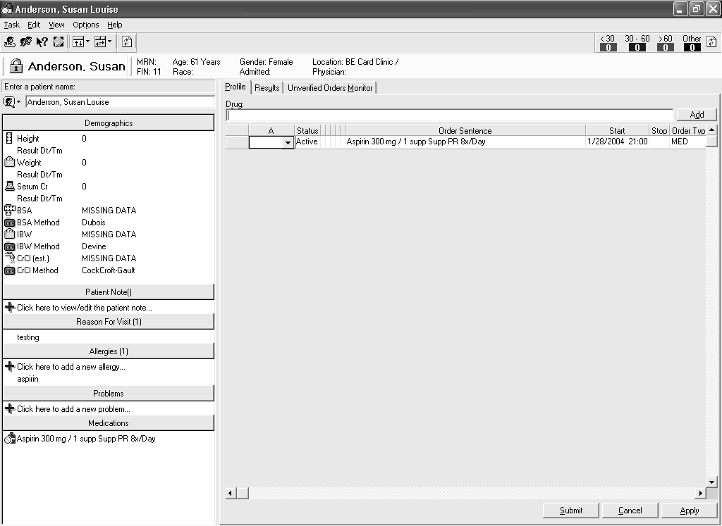
1
2
3
5
4
6
1. Search Box:
The Search box is used to search for a patient. You can search for a patient by name, financial number (FIN), or medical record number (MRN). The default is to search by patient name. To change search method, you can click Search by button and select the search method you want to use.
2. Clinical Summary Information Bars:
Below the Search box is a list of bars that segment various patient-specific, clinical information. These include Demographics (such as height, weight, and other pharmacy-specific demographics), Patient Notes (such as patient’s condition, medical treatment, or drug therapy), Reason for Visit, Allergies, Problems, and Medications.
3. Profile Tab:
The Profile tab enables you to review, enter and modify pharmacy orders as well as perform profile actions on the patient’s order profile.

4. Results Tab:
The Results tab enables you to view results entered for a patient in various clinical areas, such as the laboratory or radiology department. Essentially, it is a view of the Cerner PowerChart Flowsheet for that patient.
5. Unverified Orders Monitor Tab:
With the 2004.01 code, the Unverified Orders Monitor application was pulled into the Medication Manager application. The Unverified Orders Monitor tab was added to the Medication Manager, enabling you to monitor and review unverified pharmacy orders while continuing your work in Medication Manager.
6. Mini Monitor:
The Mini Monitor enables you to view the number of unverified orders for each time range you set up. This view of unverified orders can help you to monitor for priority items without interrupting your workflow. The Mini Monitor can be set to refresh on a regular basis. You may manually refresh the Mini Monitor by clicking the Refresh Unverified Orders button.
7. Patient Information Box:
The Patient Information box displays the patient’s name, MRN, Age, and other relevant patient demographic information.
Using Batch Dispense
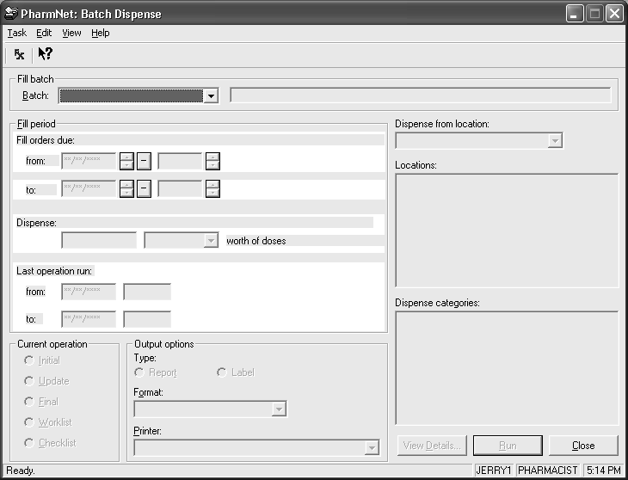
2
3
4
1
5
6
7
1. Fill Batch Box:
The Fill Batch box enables you to select the fill batch you want to run. Once you have selected a batch, a description of the selected fill batch displays in the box to the right of the Batch list.
2. Fill Period:
The Fill Period box displays the start and end dates, as well as the time for the fill period. The Dispense box and list display the numeric value used to define the fill period (the amount of time during which these doses are to be administered during this fill batch). The dispense list displays the time unit used to define the fill period. Finally, the Last Operation Run box displays the type of fill operation previously run (whether it was the initial, update, worklist, or checklist) and the start and end dates and time.
3. Current Operation:
The Current Operation box enables you to select what type of fill operation you plan to run: Initial, Update, Final, Worklist, or Checklist.
4. Output Options:
The Output Options box enables you to define the type of output you want printed: print a fill list report or print a series of fill labels.
5. Dispense From Location:
This list displays the pharmacy location or dispensing device associated with this fill batch.
6. Locations:
The Locations box displays the patient locations included in the fill batch for which pharmacy orders are dispensed.
7. Dispense Categories:
The Dispense Categories box displays the dispense categories included in the fill batch.

Using Batch Report
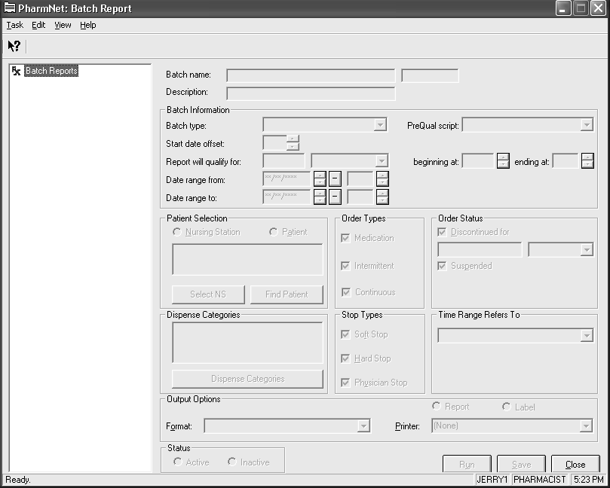
3
5
7
6
1
2
3
4
9
8
10
1. Batch Report Tree:
The Batch Report tree displays an alphabetic list of reports and patient cassette labels. You can view details for a report or label by selecting it in the tree. Once you select a report, the Batch Report name, the report number, and a brief description display.
2. Batch Information:
The Batch Information box includes more details regarding the batch including the Batch type (report or label), the offset date number, and the from and to date ranges and times.
3. Patient Selection:
The Patient Selection box enables you to define the patient or group of patients for which you want to print reports or labels. You can select one or more nursing stations or a specific patient.
4. Order Types:
With these options, you can indicate what type of orders you want included in your report: Medication, Intermittent, or Continuous.
5. Order Status:
The Order Status box enables you to indicate orders of a specific status to be included in the report. For example, you can include (or not) orders with a discontinued and suspended status.
6. Dispense Categories:
The Dispense Categories box enables you to define which dispense categories you want included in the report.
7. Stop Types:
These options enable you to include (or not) orders that have a soft, hard, or physician stop associated with them.
8. Time Range Refers To:
Time Range Refers To enables you to indicate the type of time range used for the report or label such as administration times or start dates.
9. Output Options:
The Output Options box enables you to define the type of output you want printed: print a fill list report or print a series of fill labels.
10. Status:
The Status box enables you to define a report or label as active (indicating the report or label is available for printing) or inactive.
Using Charge/Credit
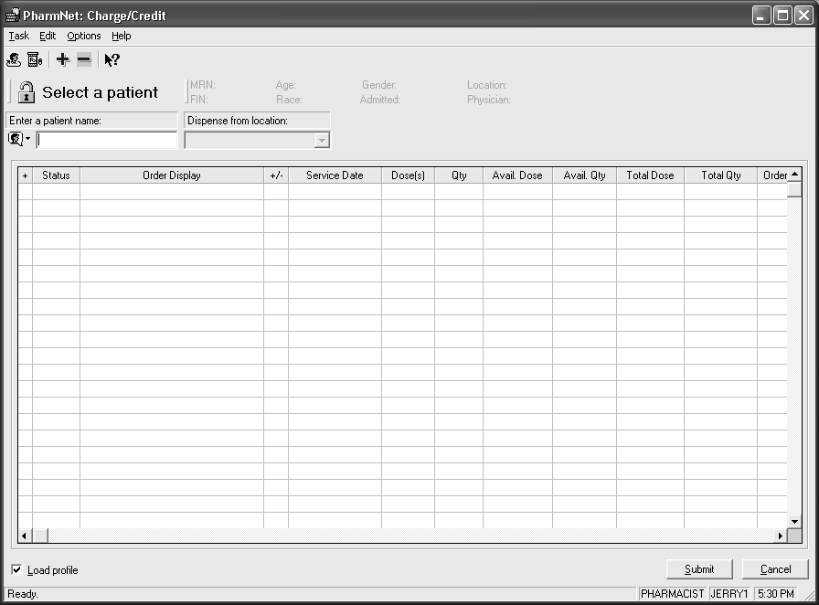
2
3
1
1. Patient Information Box:
The Patient Information box displays the patient’s name, MRN, Age, and other relevant patient demographic information.
2. Search Box:
The Search box is used to search for a patient. You can search for a patient by name, financial number (FIN), or medical record number (MRN). The default is to search by patient name. To change search method, you can click Search by button and select the search method you want to use.
3. Orders Spreadsheet:
The Orders spreadsheet displays a list of pharmacy orders for which you can submit charges or credits. You can also view the history of charges and credits and copy and paste charges between orders for a patient. The Orders spreadsheet includes additional order details such as order status, specific order details (for example pharmacy product, dose, route of administration), and service dates. To charge or credit a dose, the tool requires you to enter a plus sign (+) for a charge and a minus sign (–) for a credit, the number of doses you want to charge or credit, and the quantity of units of the pharmacy product in the dose you want to charge or credit.

Integration
The PharmNet applications offer many benefits as a stand alone solution, but the benefits are significantly increased when integrated with other Cerner solutions.
RECOMMENDED READING GUIDELINES:

The Integration chapter is recommended for all participants.

Integrated Medication Process
More common integration points for the PharmNet solutions are with the following Cerner solutions, pulled together to support the Medication Process.
PowerOrders
Providers, including residents, medical students, and nurses, enter orders online using the Cerner PowerOrders application. This application is accessed within the PowerChart Patient Chart functionality.
PowerChart
PowerChart is a family of system solutions that enable a wide assortment of provider access to clinical information. PowerChart enables providers manage their patients. This is accomplished using the Patient List feature of the PowerChart Organizer. Incoming information such as new orders, new results, and patient activity tasks can be monitored using either the Inbox (typically used by physicians) or the Patient Access List (PAL) (typically used by nurses). The PAL also supports providers, particularly nurses, in documenting patient activity such as medication administration and other such tasks.
The PowerChart Patient Chart enables providers to review the patient record including patient demographics, allergies, and history, as well as clinical results such as lab and radiology results and documented information such as assessment information and other clinical notes. This information is typically accessed through the Flowsheet, Clinical Notes, and the Form Browser. The eMAR (electronic Medication Administration Record) is also available from the patient chart. The eMAR enables providers to view and chart all active medications (scheduled, PRN, and Continuous Infusions) for a specific patient.
Discern Expert and Adverse Drug Event Prevention Solutions
Discern Expert ® and Adverse Drug Event Prevention Solutions alert providers to potential contraindications during the order entry process. These solutions, when implemented in the pharmacy, can significantly improve patient safety, clinical efficiency, and cost savings. During pharmacy order entry and order verification, times when the pharmacy staff is working in the system with one specific patient, these solutions alert pharmacy staff of potential interactions or adverse drug events (ADEs). In addition, automated rules can be set to alert pharmacy staff of potential ADEs as new clinical information is available in the system, even for patients not currently being worked with in the system! As information is updated in the system and an alert is triggered, an ADE report is automatically printed in the pharmacy to help pharmacy staff identify and avert avoidable medical errors before they occur.

Resources
There are a number of resources you can use to support the design and build of the PharmNet applications. The recommended, most up-to-date, and accessible of these resources is the Cerner Millennium Support Guides for PharmNet.
RECOMMENDED READING GUIDELINES:

The Resources chapter is recommended for all participants.

Cerner Millennium Support Guide (CMSG)
The Cerner Millennium Support Guide (CMSG) is the online reference library for Cerner Millennium solutions; providing application, process, upgrade, and technical documentation.
The CMSG is accessible from Cerner Knowledge Network (CKN) and myCerner. From CKN, the CMSG is accessed using the link in the left-hand navigation under Service / Troubleshooting or using the link listed in Quick Picks the right side of the CKN home page. From myCerner, select the Solutions or IP Development tab and click the link listed in Quick Picks (it is the first item listed).
The CMSG is organized into seven categories: Applications, Technology, Upgrade, Discern, System Integration, Process, and Knowledge & Content. Each category is subdivided into appropriate books and chapters to enable you to locate information quickly. Although each category provides information you will likely need and use the course of your work, the two categories you will use most frequently are the Applications and Process tab.
The Applications tab is organized by application. Each application book includes the following chapters: Overview, Design, Build, Special Topics, Validation, User Training, Conversion Preparation, Postconversion, and Troubleshooting. You will notice that documents are further subdivided according to the Cerner Millennium release. Currently, the CMSG subdivides its documents into those that support Cerner Millennium release 7.8 and earlier and those that support release 2003.01 and later (M2003-2004). This category typically includes links to the data collection worksheets used in the database design phase.
The Process tab currently is organized according to the major areas within the Providing Care space: Acute Care, Ambulatory, Emergency Care, and Pharmacy. The category also includes an introduction to the Providing Care solutions and to the Solution Design Methodology. Each of the books, aside from the introduction books, is sub-divided into chapters that focus on a particular process that supports that area of care. Again, these chapters are further broken down into sub-processes and typically include a process description and a process map.
Documents in the CMSG are published at the beginning of each month. All available updates are published at this time as well. Most documents are viewed using Adobe Acrobat and can be downloaded to your desktop for further review. All CMSG documents follow Cerner document control procedures to comply with document control regulations.
.

Readiness Assessment
Please complete the Pharmacy Concepts Readiness Assessment prior to the beginning of your PharmNet Inpatient Design and Build - Basics. Note that ONLY the first thirty minutes of the PharmNet Inpatient Design and Build – Basics course will focus on the content within this guide. For this reason, it is critical that you complete the work associated with this self-study and the readiness assessment itself prior to the beginning of the course.
RECOMMENDED READING GUIDELINES:

The Readiness Assessment chapter is recommended for all participants.
- Launch MyMedEd and select My Learning Plan from the menu on the left side of the screen.
- On your Learning Record, locate the line item for Pharmacy Concepts. There will be a link at the end of that line called Before Class/More Info; click this link.
- There assessment is displayed as a ‘before class’ item. Click the link for the Pharmacy Concepts Readiness Assessment.
- Complete the readiness assessment PRIOR TO THE BEGINNING OF YOUR PharmNet Inpatient Design and Build – Basics course. The first thirty minutes of the PharmNet Inpatient Design and Build – Basics course will focus on the content within this guide.

Glossary of Terms
administration time. In PharmNet, the time at which a medication, continuous, or intermittent order is administered to a patient. A nurse or other healthcare professional records the administration time on the medication administration record (MAR).
RECOMMENDED READING GUIDELINES:

The Glossary of Terms chapter is recommended for participants with less than one to two years of pharmacy-related experience.
adverse drug event. A potentially harmful patient event that is the result of medication administration. This can be caused by inadequate knowledge or by a medical error.
average wholesale price. The average price of a drug agreed upon by the manufacturers. In PharmNet, the drug reference database provides information on the average wholesale price of a drug.
continuous order. One of the three order types used in the PharmNet system. Continuous orders are orders marked by uninterrupted infusion over a period of time. For example, a large volume parenteral can be a continuous order. Rate is used to distinguish continuous orders from other order types.
cost basis. The source of medication costs used in a pharmacy order. Average wholesale price and acquisition cost are examples of cost bases. Within the PharmNet system, average wholesale price is determined by an outside source such as the Multum drug reference database. Additional cost bases can be defined using PharmNet Database Solutions.
cost range. A set of costs defined by a lower and upper limit. More specifically, in PharmNet, the values between the lower and upper limits set in the From Cost and To Cost columns of the DB Price Schedules spreadsheet.
creatinine. A chemical (C4H7ON3) found in the blood and passed in the urine that is the decomposition product of the metabolism of phosphocreatine (C4H10N3O5P). The normal serum creatinine range is 0.6 . 1.2 mg/dl. Values above this range may indicate the presence of renal disease.
creatinine clearance test. A blood or blood-and-urine test that measures the level of serum creatinine (C4H7ON3); it is used to assess kidney function. Values above 1.2 mg/dl may indicate the presence of renal disease.
discontinued order. In PharmNet, a pharmacy order that was stopped by a physician, pharmacist, or clinician, or because its course of therapy has been completed. For example, an order can be discontinued for an antibiotic when the patient has completed the course of therapy.
dosage. In PharmNet, the defined frequency, amount, strength, and quantity for a medication.
dosage form. In PharmNet, the pharmaceutical form in which the prescribed dose of a drug is dispensed. Dosage forms are created to deliver the preferred concentration of a drug and, at times, to produce a long-acting or time-delayed effect. Dosage forms include items such as ampules, caplets, capsules, inhalers, lotions, powders, solutions, suppositories, syringes, and tablets.
dose. The amount of a drug or drug therapy; or in RadNet®, the amount of radiation to be administered at one time.
drug. A product intended for use in the prevention, diagnosis, and treatment of disease.
drug/drug interaction. A reaction that occurs when two or more drugs are taken simultaneously. This reaction may be a change in the effectiveness, toxicity, or rate of metabolism of any or all of the drugs administered. The result may be an adverse drug event.
hard stop. The date and time when a medication order will be automatically discontinued, unless a prescribing authority requests that it be continued prior to the stop date.
infusion. Any sterile fluid other than blood introduced into the body through a vein.
intravenous infusion. A solution introduced through a vein to create a route of administration for drugs or replacement fluids. This route of administration is maintained by natural fluid flow, by gravity, or by pumping.
intermittent order. One of the three order types used in the PharmNet System. Intermittent orders are intravenous orders defined by short periods of infusion that are interrupted before the next scheduled administration time. An intravenous piggyback is an example of an intermittent order. The set of attributes required to correctly distinguish intermittent orders from other order types includes rate, infuse over value, and total volume.
MAR. MAR is an acronym for medication administration record, which is a report that serves as a legal record of the drugs administered to a patient at a facility by a nurse or other healthcare professional. The nurse or healthcare professional signs off on the record at the time that the drug or device is administered. This report also documents that appropriate therapy is provided to the patient.
medication order. One of the three order types used in the PharmNet System. Medication orders are distinguished by administration at a discrete moment in time, whether once or at regular intervals. Examples of medication orders include tablets, capsules, suppositories, and syringes. The presence of frequency, without rate, infuse over value, or total volume distinguishes medication orders from other order types.
order type. An order type is a category used to classify pharmacy products on the basis of how they are ordered, in particular, on the basis of a set of attributes that varies from one order type to the next. The three order types available for selection in the PharmNet system are continuous, intermittent, and medication.
parenteral infusion. A sterile fluid, medication, or nutrient that is introduced to the body through a route other than the alimentary canal. Typically, a parenteral infusion is introduced intravenously and provides nutritional support when patients cannot eat.
patient medication profile. A printed report that lists all drugs prescribed for a patient, which may contain active, suspended, or discontinued orders. The patient medication profile can be used to support the healthcare facility, in case of a system failure or power outage, to ensure that patients receive appropriate drug therapy.
pharmacy and therapeutics committee. A governing body within a healthcare facility (often referred to as the p and t committee) which determines which drugs, drug delivery devices, and drug administration devices will be included in the facility’s formulary. The p and t committee includes physicians, pharmacists, and other healthcare professionals who together develop the facility’s policies regarding drug therapy and the management and administration of drugs.
price schedule. A specific set of parameters used to calculate charges for pharmacy orders. These parameters include the cost bases for medications, mark-up percentages, fixed fees, methods for calculating multiple ingredient orders, and provisions for rounding fractional figures and applying minimum prices. Multiple price schedules can be built to reflect the differences in a healthcare facility’s charging practices. Because these practices can vary according to factors such as medication type, dispense type, patient location, and even special status, the names used to identify price schedules can vary greatly. LVP, Bulk, ChemoSyringe, Employee, and NoCharge are all examples of price schedule names.
route of administration. The method of administering a drug to a patient so that the drug is absorbed and produces the preferred effect. Routes of administration can include implant, inhalation, intravenous, oral, topical, and transdermal, among others.
side effect. An undesirable effect that is the result of a drug therapy. Common side effects are dizziness, nausea, and sedation and, some can be predicted.
soft stop. The date and time when a prescriber should review a medication order. Soft stop review policies are implemented to notify a prescriber that a medication order requires review. In the PharmNet system, a soft stop date does not cause an order to be discontinued.
unit dose. A package that contains a single dose of a drug for a patient. Typically, a unit dose is packaged for one-time use and administered directly to a patient.
unverified order. In PharmNet, an order, entered in the system by a pharmacy technician or other healthcare professional that must be verified by a pharmacist. Unverified orders include all pharmacy order types (continuous, intermittent, and medication).

Sources

American Society of Health-System Pharmacists, Staffing Survey, May 2003 (http://www.ashp.org/practicemanager/StaffSurvey2003.pdf) 2.

Fok, Mark and Lo, Angela. Quantifying the Impact of Prescription-Related Problems on Pharmacy Workload. Canadian Journal of Hospital Pharmacists. 2002;55(November):313-319

Kelly, William N. Pharmacy: What It Is and How It Works. CRC Press Pharmacy Education Series. CRC Press LLC. Boca Raton, Florida. 2002.

National Association of Chain Drug Stores, 2003 News Releases, Pharmacist Shortage Continues Unabated, According To Latest NACDS Foundation Chain Pharmacy Employment Survey, July 2003 (http://www.nacds.org/wmspage.cfm?parm1=3208)

